*A Mariner White Paper*

**

**Tableau versus Power Pivot:**

**Daily Use**

*By Brad Llewellyn, Data Analytics Consultant*

2719 Coltsgate Road • Charlotte, NC 28211

tel. 704.540-9500 • fax. 704.540-9501

[www.mariner-usa.com](http://www.mariner-usa.com)

[Description: Linkedin](http://www.linkedin.com/in/javierguillen) [Description: Twitter](http://twitter.com/javiguillen) [](http://blog.mariner-usa.com/) [Facebook](http://www.facebook.com/pages/Mariner/189095341130729)

©2013 MARINER, All Rights Reserved.

Contents of this document are proprietary and may not be distributed without the prior written consent.

# Contents

Abstract 3

Point-and-Click KPIs 4

Performance 10

Basic Dashboards 18

Sharing 31

Results 41

About the Author 42

Brad Llewellyn, Data Analytics Consultant 42

About Mariner 42

Copyright Information 42

# Abstract

The purpose of this white paper is to compare two of the leading tools for Self-Service BI, Tableau and Power Pivot. There seems to be a stigma around these tools saying that Tableau is a visualization tool and Power Pivot is a data modeling tool. Is this really true? That’s what we’re here to find out. This type of examination was done about three years ago.  Click [here](http://sqlmag.com/blog/microsoft-powerpivot-vs-tableau) if you would like to read it.   Many of the flaws listed for Tableau have been worked out in the newer releases, while Power Pivot has not gotten the same treatment.  This is a major issue when comparing purchased products to free products.  However, our examination is from the user's perspective.  This means that current and future functionality must be considered, as well as pricing.

In this paper, we will examine the following types of tasks in these tools, Point-and-Click KPIs, Performance, Basic Dashboards, and Sharing. If you are in a rush, the results can be found in the Results section. However, if you are serious about examining these two products, then you should definitely take the time to read this. Don’t be overwhelmed by the page numbers. We are examining two very visual tools from a user’s perspective. Therefore, there are a lot of pictures. We welcome you to join us as we get to the bottom of this question, once and for all.

This is the second white paper in the series. If you haven’t read the first one, it can be found at <INSERT LINK HERE>. We hope you enjoy these examinations!

# Point-and-Click KPIs

In this section, we will talk about what we are calling "Point-and-Click KPIs."  These are calculations that can be performed using built-in non-coding functionality within these two tools.  To be a little clearer, Power Pivot has a feature called "KPI," which allows the user to quickly compare measures to goals with nice visual output.  On the other hand, Tableau has a feature called "Quick Table Calculation," which allows the user to quickly create some advanced calculations with only a few clicks.

In our previous post, we compared the tools on how you could programmatically create some simple KPIs.  In other words, we compared "apples to apples."  In this post, we will be comparing related features of these tools that are not quite so easily compared.  Therefore, there will be no winner assigned in this section; it is purely for informational purposes.  On another note, the term KPI takes on somewhat of an ambiguous meaning in this post.  We typically refer to run-time calculations as KPIs.  It turns out that Power Pivot's feature is also called KPI; however, we'll try to be deliberate about our word choices.  Now, let's get on with the examination.

**Power Pivot KPIs**

In the Power Pivot ribbon (among other places), you will see an icon that says "KPI."  Clicking on this icon will allow to select "New KPI" or "Manage KPIs."  Click on a KPI, or creating a new one, will open up the following window:

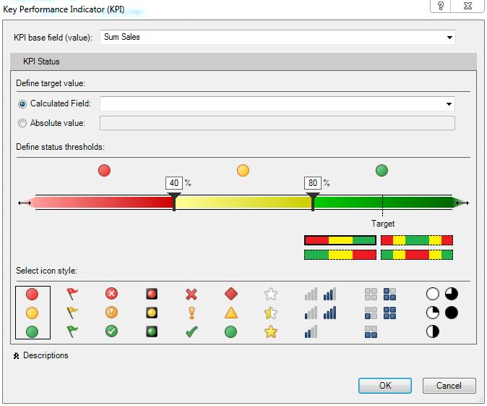

KPI Window (Power Pivot)

As you can see, this window allows you to define your base value, a goal (calculated or absolute) and a display mechanic to be associated with that KPI.  The KPI will calculate a simple ratio to determine how close the base value is to the goal.  You can adjust the acceptable percentages using the sliders on the multi-colored bar in the middle of the window.  You can also change how the bar is arranged to allow for a little bit more flexibility in your KPI.  Now, let's create a KPI that compares this year's sales to last year's sales.

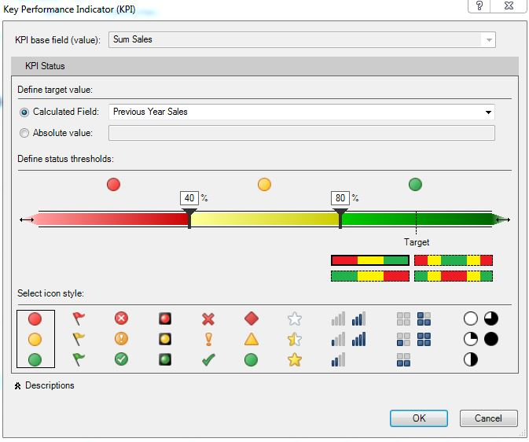

Sum Sales KPI (Power Pivot)

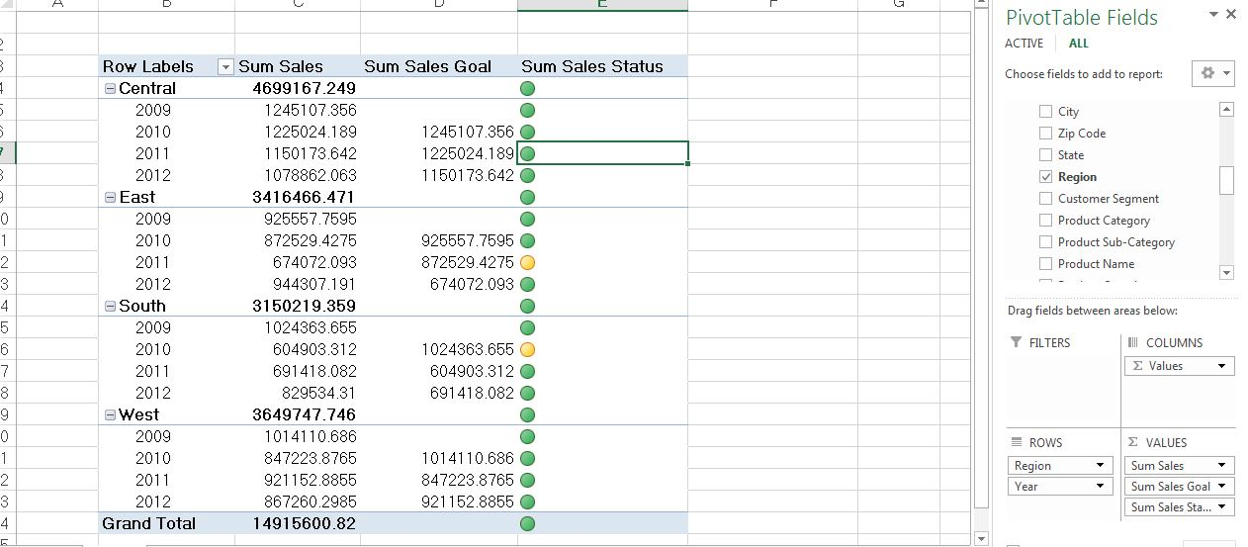

Sum Sales KPI by Region and Year (Power Pivot)

Now, we can see which years saw a decline in sales for eachrRegion.  There are a couple of things to note about this feature.  First, you can only have one KPI per measure.  If you want to compare this year's sales to last year's sales and this year's sales to this year's budget, you will need to duplicate your measure for SUM( [Sales] ).  Second, you need to create each underlying measure individually and you cannot use implicit measures.  Third, if you select any display styles other than the default Red-Yellow-Green Circles, Excel will still display them as Red-Yellow-Green Circles.  You can change the display style by editing the conditional formatting.

This feature is not very useful within Excel.  The KPI calculation can easily be made using [Base] / [Goal].  Also, the target audience for Power Pivot is Excel power users.  These power ssers should already have a good understanding of how to create conditional formatting.  Therefore, we don't see many people using this feature inside of Excel.  However, this feature does become useful when you are creating dashboards inside of Power View, which does not have built-in functionality for conditional formatting.  When you are using these KPIs inside of Power View, you will see that changing the display style of the KPI will be reflected in your dashboard.

So, we will end this examination by saying that this feature is a neat, albeit weak, addition to the Power View Dashboard toolkit.  It allows the users to spice up their text tables to add that next level of usability, and we all know that text tables are an Excel users’ best friend!

**Tableau Quick Table Calculations**

Whenever you drag a measure onto a chart in Tableau, you can right-click the measure and select, "Quick Table Calculation."  This will open up a list of common calculations that Tableau will calculate for you.

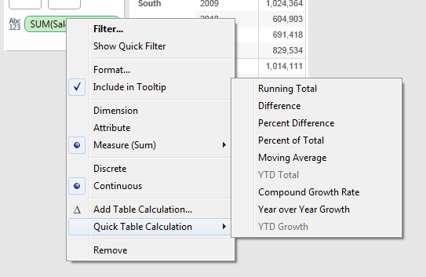

Quick Table Calculation (Tableau)

If you select a calculation, Tableau will replace the measure on your chart with the calculation you selected.  Now, let's calculate year over year growth using this feature.

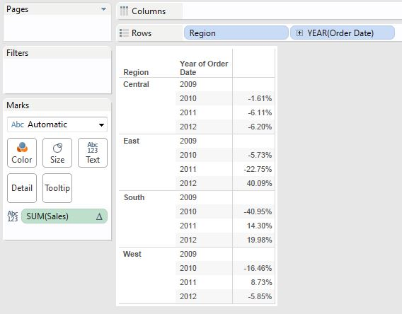

Year over Year Growth by Region (Tableau)

This took one click and we have a calculation that most people would have to think about how to calculate.  This calculation would also take some knowledge of table calculations to create on your own.  What if you wanted to know how Tableau calculated this value?  Right-click the SUM( [Sales] ) pill on the Text Shelf and select "Edit Table Calculation," then select "Customize."  This will open up the Calculated Field window where you can see the exact syntax for creating this calculation.  In fact, this is how we learned table calculations when we were first getting started.  It should also be noted that this feature can be used on implicit measures, like SUM( [Sales] ), or any calculated fields you want to create, except for other table calculations.  All in all, this is an extremely easy way to create most of the common calculations you would want, and it's not a bad way to improve your Tableau skills either.

**Section Summary**

Power Pivot's KPI feature is an easy way to add a little color and readability to your Power View dashboards.  It also allows you to easily create and maintain simple indicators in one central location.  On the other side, Tableau's Quick Table Calculation feature allows the user to create some complex calculations such as year over year growth and moving averages with only a couple of clicks.  It is also useful for learning how to better utilize table calculations in Tableau.

# Performance

In this section, we will look at how each of these tools handles very large data sets.  We are going to examine them on how compactly they store the information as well as how quickly they can retrieve it.  Unfortunately, we cannot give any information on the source of this data set, we can only say that it is an enterprise fact table with 53.5 million rows, 22 columns, and takes up almost 8GB as a csv text file.

Now's the time to note some limitations in the tools.  Tableau and Power Pivot both have limitations on the data they can connect to.  In a 32-bit environment, Power Pivot is unable to connect to any data source larger than 2GB.  This was a design choice by the developers to keep Power Pivot in the "Self-Service BI" freeware niche.  If you want to work with data sources larger than 2GB, you should upgrade to a 64-bit environment or a BISM Tabular model.  BISM Tabular is basically Power Pivot all grown up.  It is a much more powerful version of Power Pivot that you would need to buy from Microsoft.

On the other hand, Tableau is designed as an enterprise tool as well as a self-service tool.  Therefore, when your file reaches the limit, which we think is also around 2GB, then you still have the option of creating a, "Tableau Data Extract."  This is a proprietary file format which includes columnar compression and storage, similar to Power Pivot.  Also, we have never seen a limit to the size of Tableau data extract.  The only limitation we have seen is of the processing power of your machine.

Now, let's talk about our examination.  We uploaded the data into SQL Server and typecasted the top ten million rows from strings into numbers to keep the size under the limitations of the tools.  Please note that these tests are done using a single laptop PC with 8GB RAM.  Your results may vary.  A recap table will be provided at the end of this section.

**Category 1: Initial Data Upload**

The first step to our process was to upload the data into our tools.  In Power Pivot, this involved loading the data into the Power Pivot window.  In Tableau, this involved creating a Tableau Data Extract.  Here are the times:

Power Pivot: 2 minutes

Tableau: 3 minutes 43 seconds

As you can see, Power Pivot uploaded the data much more quickly.  Data Upload is separated into two steps: Retrieval and Compression.  Power Pivot was about 30 seconds quicker at retrieving the data than Tableau was.  Moreover, Power Pivot compressed the data in a matter of seconds; whereas Tableau took about a minute to complete this process.  All in all, Power Pivot wins this part.

*Winner: Power Pivot*

**Category 2: Data Refresh**

Now that the data is in the tool, how quickly does it refresh?  Let's find out.

Power Pivot: 2 minutes 10 seconds

Tableau: 4 minutes 2 seconds

This is the same story as before.  No commentary needed.

*Winner: Power Pivot*

**Category 3: Saving the Workbook**

An important part of a business analyst's job is saving their work.  Let's see how these tools fare. For this category, we saved the Excel workbook and saved a Tableau Packaged Workbook.

Power Pivot: 15 seconds

Tableau: 7 seconds

We're not sure why Tableau saves faster than Power Pivot.  It probably has something to do with the fact that Excel workbooks contain many more features than Tableau workbooks.  Regardless, this is an easy call.

*Winner: Tableau*

**Category 4: Opening the Workbook**

When you arrive at work the next morning, you need to be able to resume your work.  Let's check them out now.

Power Pivot: 15 seconds

Tableau: 4.5 seconds

Tableau takes this one as well.  This victory is probably caused by the same features as the quicker saving was.

*Winner: Tableau*

**Category 5: Compressed Data Size**

Now, let's look at how large these workbooks are when they only contain the compressed data.  This should be a good benchmark to compare the different compression algorithms.

Power Pivot: 247 MB

Tableau: 73 MB

It seems we have found the reason why Tableau saves and opens faster.  Its workbooks are much smaller.  This is likely due to the many extra features contained within Excel and the fact that Tableau spent much more time compressing its data, leading to a smaller extract.

*Winner: Tableau*

For the next three sections, we were unable to find a great way to simply refresh a chart from Power Pivot. Therefore, we chose to open the workbooks to a blank sheet without updating any of the other sheets. Then, we switched from the blank sheet to the appropriate chart and timed how long it took for the refresh to finish.

**Category 6: Tabular Chart Refresh**

Next, let's see how quickly these tools can refresh a very large tabular chart.  Note that these charts were made using a Pivot Table in Excel versus a Text Table in Tableau.

Power Pivot: 22 seconds

Tableau: 43 seconds

We see that Tableau is much slower at refreshing this table than Power Pivot.  This must be the performance that everyone talks about when they talk about Power Pivot.

*Winner: Power Pivot*

**Category 7: Bar Chart Refresh**

Finally, we're getting to the good stuff.  We saw that Excel was fast at creating Pivot Tables.  The question is, "Will Power View fare as well as Excel?"  Let's see how it goes.

Power Pivot: 6.5 seconds

Tableau: <1 second

The Tableau chart loaded so quickly that we couldn't even time it with a stopwatch.  This is easy to call.

*Winner: Tableau*

**Category 8: Dashboard Refresh**

Finally, we get to the main event.  How quickly can these tools load a complete dashboard?  Note that the dashboard consisted of four varying types of charts created to stretch the tools.

Power Pivot: 9 seconds

Tableau: 3 seconds

It seems that Tableau has won again...Wait a minute!  Notice how the difference between times for Tableau and Power Pivot for the Bar Chart and the Dashboard are 6 seconds for each tool?  Turns out, this is actually caused because switching between Power View sheets in Excel causes a little bit of overhead.  Since Power View is a separate entity from Excel, opening Excel does not mean that you have also opened Power View. Therefore, this 6 second window could be attributed to the overhead needed to open Power View. This delay does not exist when you are working with a chart inside of Power View. Therefore, this would be a one-time delay for the user. Alas, winning is winning.

*Winner: Tableau*

**Section Summary**

Let's take a look our results to see how the tools matched up.

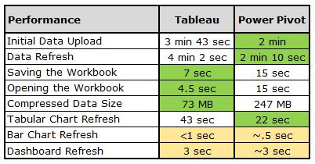

Performance Results

Looking at quantity of category wins, it seems that Tableau is the winner.  However, if we look at the categories that really matter, Initial Data Upload and Data Refresh, Power Pivot takes this one.  This puts us in a bit of quandary.  Which of these tools is the winner?  If we consider our original idea of the 53 million row data set, we see that Power Pivot was completely unable to deal with this quantity of data, while Tableau had no issues at all.  So, we can finish with a two-part decision.  If you are using small data sets by yourself for a side project, you will probably see better results with Power Pivot.  However, once you reach a certain point, you must use a different tool.  This means that for larger data sets, Tableau wins.

# Basic Dashboards

In this section, we will talk about creating dashboards in Tableau versus creating dashboards in Power Pivot and Power View.  To keep things basic, we will create dashboards that consist of a few related charts with some basic linking (filtering) and brushing (highlighting) features.  For those of you who are avid readers of our work, you will note that we do not recommend these types of dashboards.  They are much less useful than they could be.  However, they are what the vast majority of business users tend to create.  As usual, we will use the superstore sales sample data set from Tableau.

This test will have three criteria: ease of use, functionality and aesthetics.  However, before we can begin the test, we need to design our dashboard.  Let's start with a map of profit by state.  This map will lead you to a list of customers within that state, as well as how much profit they have generated and how many orders they have placed.  Finally, this chart will lead you to a table with information about all of the orders that customer has placed.  Now, let's see how Power Pivot handles this.

**Phase 1: Power Pivot**

First, let's try to create our map.

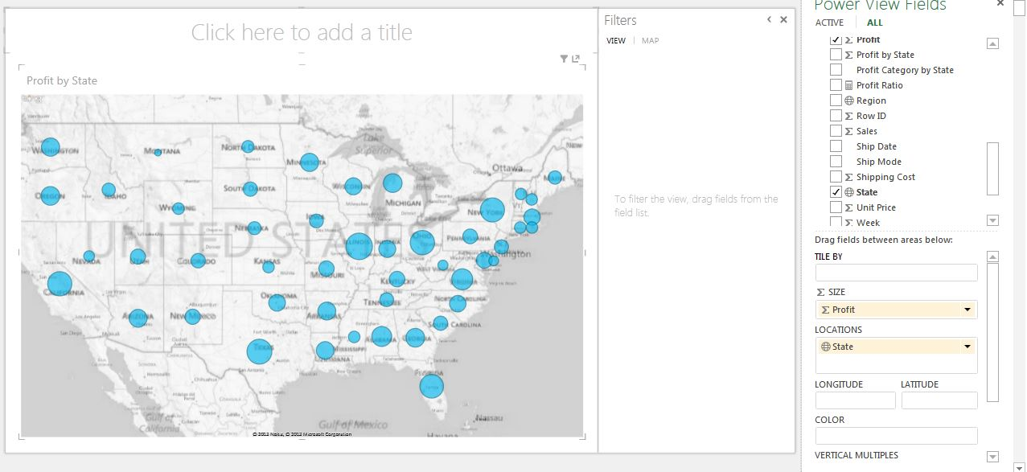

Profit by State (Power Pivot)

This looks decent.  However, a little color would be great to distinguish the profitable states from the unprofitable ones.  To do this, we need to create a calculated column with some type of discretization of profit by state.  First, we need to create a calculated column with the total profit for each state.

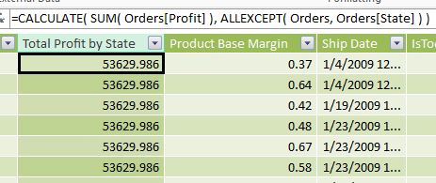  
Total Profit by State (Power Pivot)

We chose to use the ALLEXCEPT() function to do this.  There are likely other ways to do this using SUMMARIZE() or some other filtering function.  We also verified these by comparing the value for the states to the values in map.  Now that we know how much profit the state has generated, we can categorize them.  Looking at the map, we see values between -$10,000 and $100,000.  So, let's categorize them in groups of $25,000.

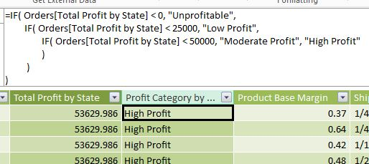

Profit Category by State (Power Pivot)

This wasn't too difficult of a task.  However, these boundaries are hardcoded and would have to be manually changed if the data was changed or refreshed.  Now, let's see how it looks on the map.

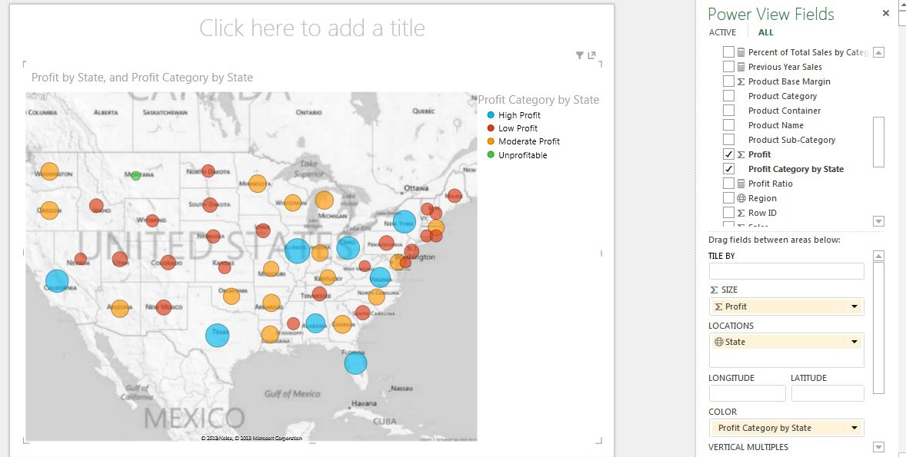

Profit by State (Improved) (Power Pivot)

This map is far more useful than the previous one.  You can easily tell which states belong to which categories.  However, we would love to be able to change the colors so that they follow a recognizable pattern, such as red-green, or blue-orange.  Alas, this is not possible in Power View.  We could create a much better map in Power Map.  However, we are saving Power Map for a more advanced investigation in a later part.

Let's move on to the bar graph of profit and number of orders by customer.   To do this, we need to create a number of orders measures.



Number of Orders (Power Pivot)

This was easy enough.  Now, let's create the bar graph.

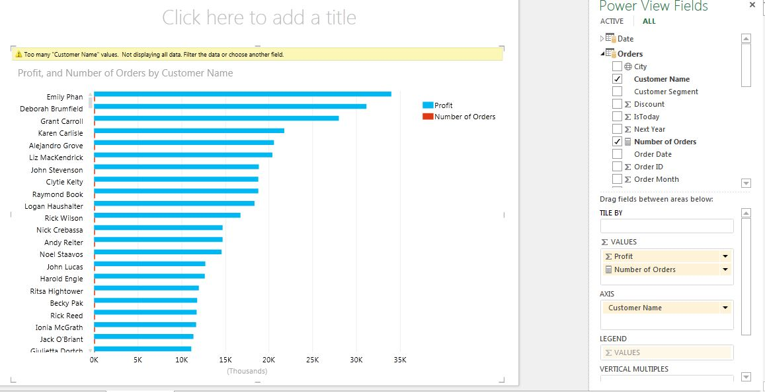

Profit and Number of Orders by Customer (Power Pivot)

This chart isn't bad.  However, we are unable to show number of orders in any reasonable way because of the massive difference in scale between the two measures.  We could put it on its own separate graph; but then we would lose the ability to sort by profit.  So, it seems that must scrap number of orders from this chart.  We also have this ugly ribbon telling us that there are too many customers to display.  We could go back and create another calculated column which tells us which customers are in the Top N%.  Although, that's a lot of work.  It's easier to just filter out customers whose profit is less than $500 and move on.  Removing possibly valuable information is not a great thing.  Alas, the tool leaves us little choice.

Finally, let's create a text table that we can filter down to each customer to show what they have purchased.

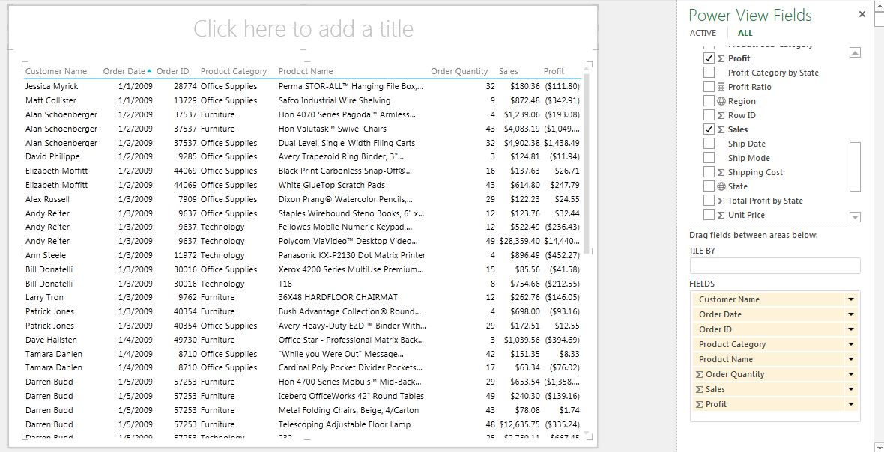

Order Details (Power Pivot)

There's nothing too complex about this table.  It would be nice to have a very light amount of color to differentiate profitable orders from unprofitable ones.  Once again, Power View is not nice enough to give us such a feature.  All in all, this is a nice dashboard.  It tells us the information we need to know, when we need to know it.

As far the dashboard construction goes, Power View automatically creates links between charts that allow for an interactive experience.  Therefore, all we need to do is place the charts on the sheet.  We'll show the final reveal at the end.  Now, let's see what Tableau can do.

**Phase 2: Tableau**

Once again, we will start with the map.

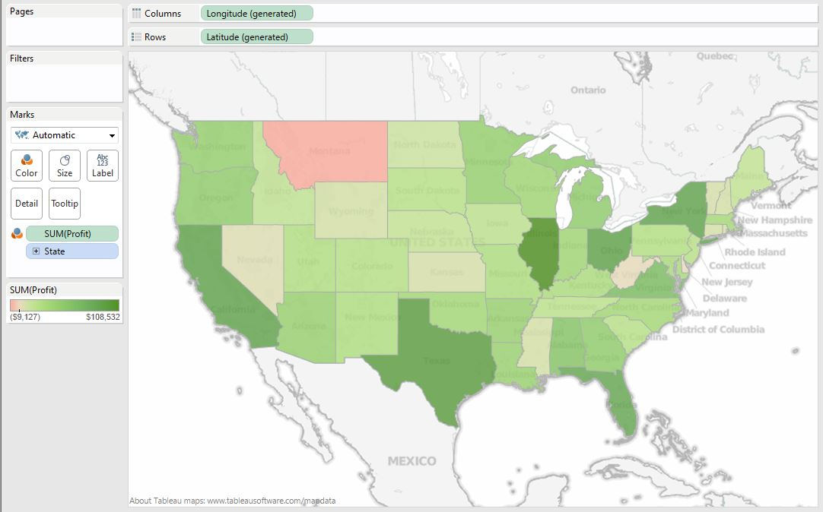

Profit by State (Tableau)

Not only did this only take a few drags, it looks significantly cleaner than Power Pivot. Next, let's try the bar graph.  The first thing we need to do is calculate number of orders.

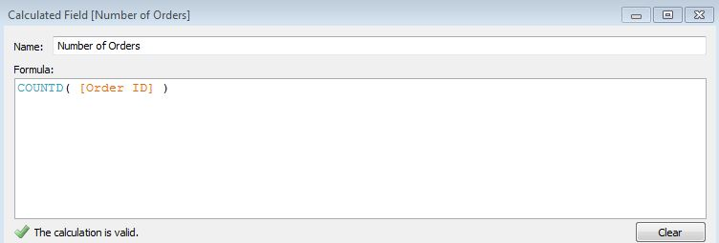

Number of Orders (Tableau)

Next, we can drag rrofit and number of orders onto the chart. We can also click the sort button and turn on labels. This yields the following chart:

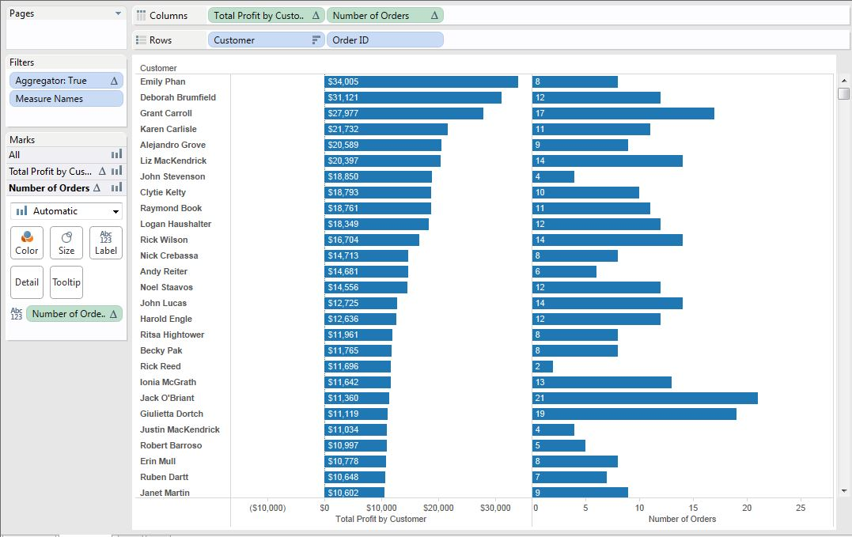

Profit and Number of Orders by Customer (Tableau)

Creating this chart was no more involved that the one in Power View, yet dominates in terms of usability and aesthetics.  Now, on to the order details table.

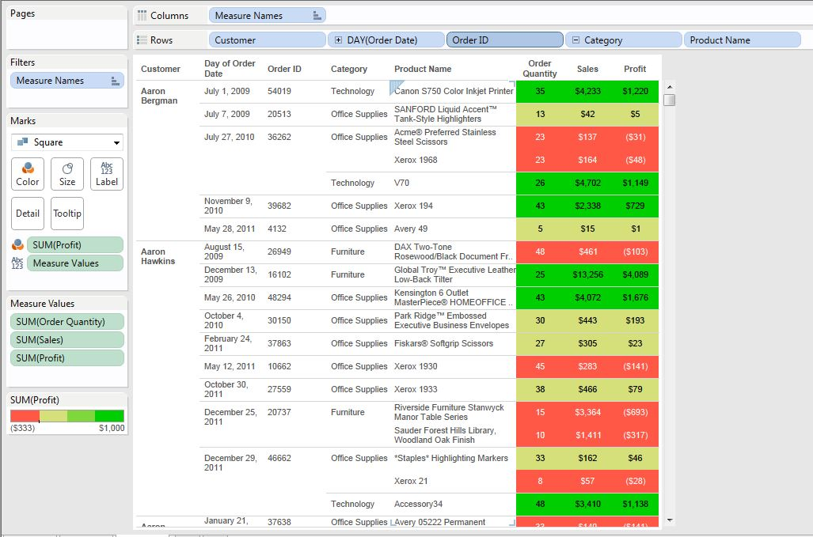

Order Details (Tableau)

As you can see, Tableau allowed us a tremendous amount of flexibility when creating this table.  This version is far more useful to the analyst than just a table full of numbers would be (which is exactly what we used in Power View).  Unlike Power View, Tableau does not automatically link sheets on a dashboard.  Each "Action," as they are called in Tableau, must be created individually.  While this is more work, it leads to a much more flexible product.  First, we need to be able to filter the bar graph and table using the map.

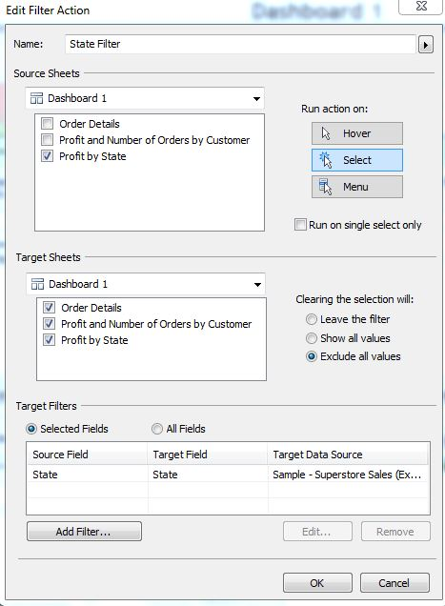

State Filter (Tableau)

This box shows us just how flexible Tableau's Action system is.  Take note of the "Exclude all values" selection.  This will allow us to demonstrate a neat trick that, to our knowledge, Power View cannot do.  Next, we need to allow the table to be filtered by the bar graph.

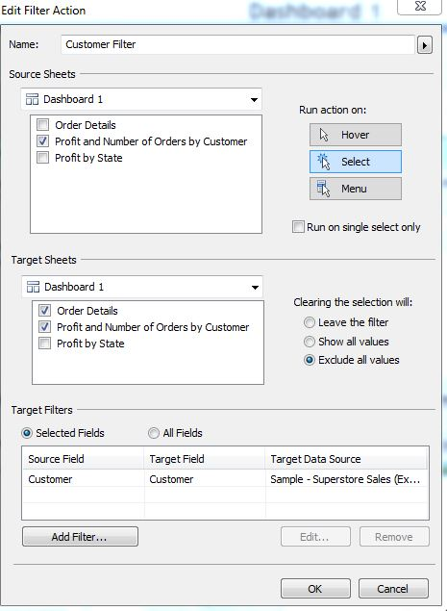

Customer Filter (Tableau)

This filter is very similar to the state filter, albeit with a few different selections.  Finally, let's move on the main event.

**Phase 3: Dashboard Showdown**

First, let's see how Power View turned out.

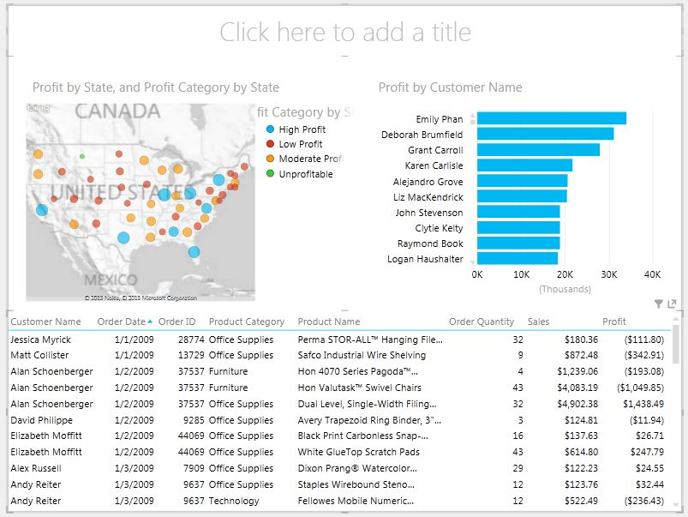

Power View Dashboard (No Selections)

This dashboard looks very clean.  The white background and smooth colors give it a very professional feel.  We can easily see which states belong to which categories.  However, the color scheme is a little confusing.  Shouldn't green be a good thing?  The bar chart of customers is very clean as well.  We can easily see that there are three customers who generate more profit than the rest.  The table at the bottom is pretty useless as of now; there's way too much information in it and it's sorted by date.  Now, let's select a state and see what happens.

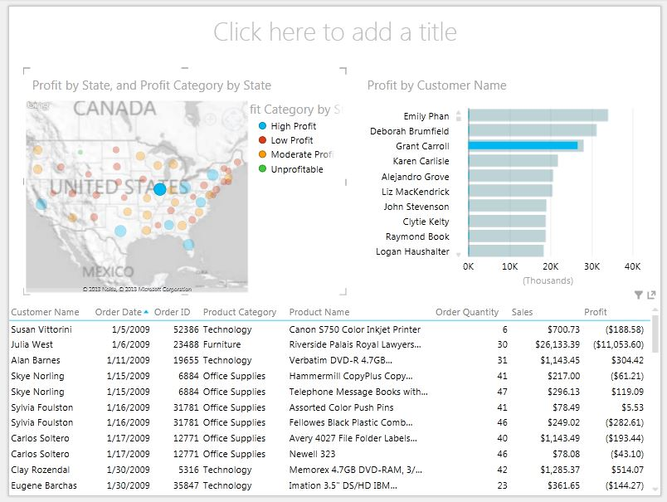

Power View Dashboard (State Selected)

The bar graph is now highlighted, showing us how much of the customers' profit is coming from this state.  The table also filtered to only show orders from this state.  It does seems somewhat difficult to find which customers actually purchased in this state, there are too many empty bars in the bar graph.  Also, the table is still far too large to be useful for any type of analysis.  Next, let's select a customer and see what we get.

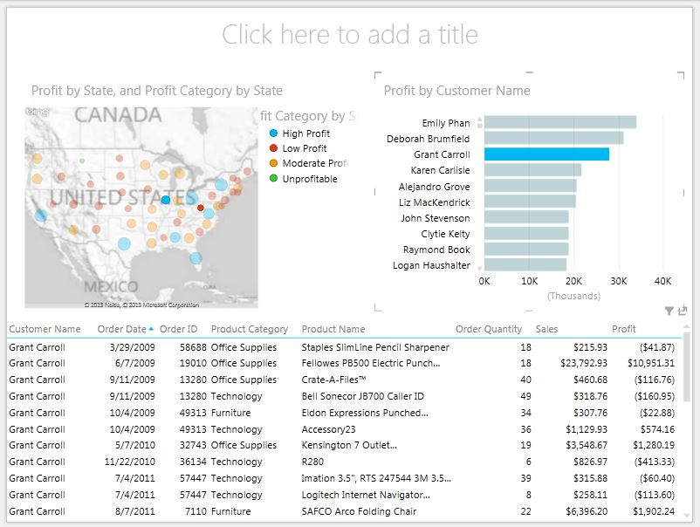

Power View Dashboard (Customer Selected)

We can somewhat see which states this customer ordered from.  However, the wild colors make this process slightly less desirable.  Finally, we see that we have a useful table at the bottom.  We can see all of the orders placed by this customer.  However, it would be nice to be able to easily see which of these orders were profitable and which were not.  All in all, this was a nice dashboard.  It was very clean and professional.  An analyst would be able to make good use of this dashboard.

Lastly, let's see how Tableau fares.

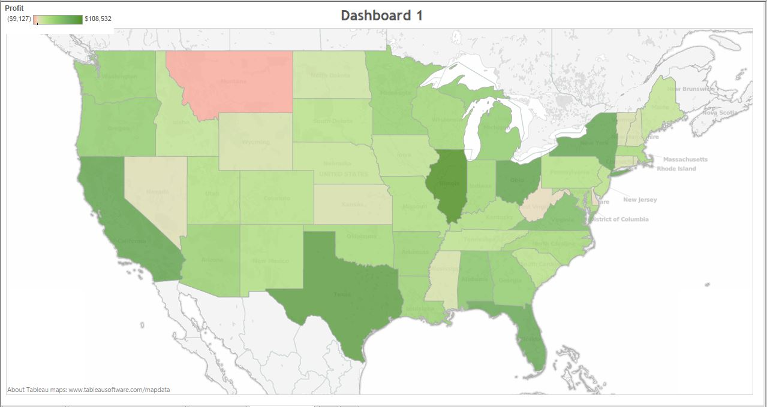

Tableau Dashboard (No Selections)

This is really crisp.  The colors are not overpowering and it is easy to see where each state ranks.  The map takes up the entire screen, which allows us to see what's going on in New England.  Let's select a state and see what happens.

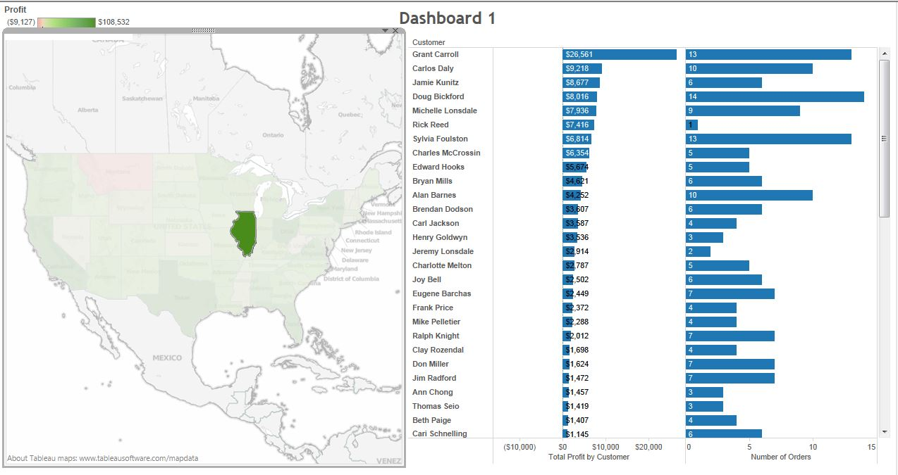

Tableau Dashboard (State Selected)

Cool!  The map automatically resized to allow room for the bar chart.  Hint: This was caused by that "Exclude all values" selection we mentioned earlier.  We can also see how profitable each of the customers were in this state.  As a bonus, we can see how many orders they placed.  Apparently Rick Reed placed one really big order, as opposed to most of the other customers, who placed a series of smaller orders.  We would have never seen that using the Power View dashboard.  Let's select a customer and see what happens.

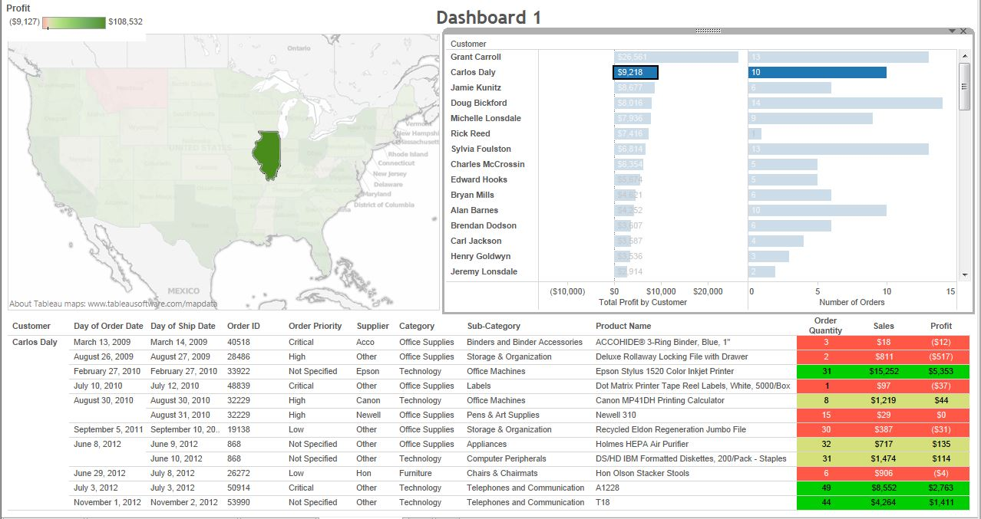

Tableau Dashboard (Customer Selected)

Everything resized again to allow room for the table.  The table also allows us to easily see which purchases were profitable and which weren't.  As an added bonus, Tableau allows us to fit more columns in our table.  Who knows when that extra information might come in handy?  There is one irritation we would like to point out.  When you select charts in Tableau Desktop, you get those borders around the chart.  It is very difficult to avoid this and we wanted to show it.  Power View also does this; but it is significantly less pronounced.  All in all, this dashboard is terrific.

**Section Summary**

It was pretty easy to see that Tableau blew Power View away when it came to dashboard functionality. On one hand, we must give credit to Power View for its simplicity.  But, we believe that Tableau demonstrated so much more flexibility and analytical capabilities that it’s not even a contest.  It is worth noting that Power View is a free tool that comes with Office 2013.  Therefore, if you are looking for a first-step into the world of visualization, at little upfront cost, then Power View could be a good start for you.

*Winner: Tableau*

If you are interested in learning how to create the dynamically sizing charts in Tableau, check out [Creating a Dashboard with Variable Container Heights in Tableau](http://breaking-bi.blogspot.com/2013/02/creating-dashboard-with-variable.html).  This post was written using Tableau 7.0; but the task didn't change much in 8.0.

# Sharing

Today, we will talk about how to share your work within these two tools.  Sharing is arguably the most important component of any analysis.  An analysis is worthless if you can't share the results with the people who need to know.  So, we are going to look at one-time sharing, data publishing, and report publishing.

**Category 1: One-Time Sharing**

Imagine that you are rummaging through your data and find an interesting pattern.  So, you compile a simple report and want to share the results at the meeting that afternoon.  The question is, "How do you transfer the report?"

The easiest way is to take a screenshot.  This can be done with almost any tool in any situation.  However, it adds no interactivity, which is a major selling point for newer reporting tools.  Power Pivot and Tableau both require that you give the workbook to someone else.  But, these workbooks are usually too large to email.  Therefore, you would need to post them on SharePoint, Dropbox, Skydrive or some other online storage medium to transfer the files.

Both of these tools also require that the reader have the appropriate software installed.  If you are giving an Excel workbook to someone who does not have your version of Excel and/or Power Pivot, you will likely run into serious issues.  The same can be said of Tableau.  If the reader does not have Tableau installed on their machine, they will be unable to see your report.  However, Tableau has one distinct advantage in that they can download Tableau Reader for free.  Tableau Reader allows the reader to interact with your Tableau workbook without being able to alter anything.  To our knowledge, there is no free software that allows someone to interact with Power Pivot/Power View reports.  Therefore, Tableau inches this one out.

*Winner: Tableau*

**Category 2: Data Publishing**

Imagine that you are an analyst who spent countless hours compiling all sorts of data in your Power Pivot or Tableau workbook.  One of your colleagues loves your work and says "Can I see your data?  I'd like to do some analysis of my own."  How do you handle this?

Regardless of which tool you are using, one option is to give him a copy of your workbook.  However, this is a one-time transfer and will likely cause issues with data consistency.

For Power Pivot, the better option is to publish your workbook to SharePoint.  When the workbook is published to SharePoint, anyone with the appropriate credentials can connect directly to the data using an Analysis Services or ODBC connection.  The only concern here is that SharePoint is not free.

Tableau has a very similar mechanic when you publish your data connection to Tableau Server.  You can publish any type of connection to the Tableau Server.  If you are using an extract, you can store all of your row-level calculations in the extract itself before you publish it.  This is referred to as "optimizing." Also, if the workbook has more than one data connection that is being blended together, these connections will have to be published separately and blended again, unless you can find a way to join them into one data source.

As an added bonus, Power Pivot allows many other tools to connect to its data.  All you need is an Analysis Services/ODBC connector.  Tableau, on the other hand, would require the user to view the data, then copy it into Excel, which can be quite a hassle if the data set is large.  In fact, it is impossible to copy more than a million rows into Excel.  Our point is this: Power Pivot allows users to model data then export it to another tool; whereas Tableau wants to be the end of the line.  It seems we have a clear winner here as well.

*Winner: Power Pivot*

**Category 3: Report Publishing**

Now, you've created an awesome report that is now the, "gold standard" for reporting in your business.  Every other analyst needs to look at your report every day to see how the current metrics/KPIs are faring.  How do you accomplish this?

These tools are almost identical in how they accomplish this task.  You can publish a Power View report to SharePoint, where you can set an automatic refresh cycle.  Tableau does the same using Tableau Server.  Seeing as how this is the designed end-game for these tools, they are nearly identical in how they accomplish this.  Also, we won't get into the caching mechanisms behind these tools.  However, we will say that they both create caches that allow users the freedom to quickly view reports once they have been initialized.

*Winner: Tie*

**Section Summary**

We saw that Tableau barely edged out Power Pivot in one-time sharing because of its free reader.  On the other hand, Power Pivot beat Tableau with its ability to share data models. Also, these tools fared equally well at publishing reports.

# Results

This examination turned out pretty well. Here are the results:

|  |  |  |  |
| --- | --- | --- | --- |
| **Point-and-Click KPIs** | **Tableau** | **Power Pivot** | **Tie** |
|  |  |  |  |
| **Performance** |  |  |  |
| Initial Data Upload |  | X |  |
| Data Refresh |  | X |  |
| Saving the Workbook | X |  |  |
| Opening the Workbook | X |  |  |
| Compressed Data Size | X |  |  |
| Tabular Chart Refresh |  | X |  |
| Bar Chart Refresh |  |  | X |
| Dashboard Refresh |  |  | X |
| **Basic Dashboards** |  |  |  |
|  | X |  |  |
| **Sharing** |  |  |  |
| One-Time Sharing | X |  |  |
| Data Publishing |  | X |  |
| Report Publishing |  |  | X |

In these examinations, we saw one overwhelming result. These tools aren’t all that different at these levels. However, we did notice that Tableau excelled at compressing and graphing large amounts of data, while Power Pivot was better at loaded/refreshing data and creating tabular charts. When it comes to creating dashboards, Power View is an easy, cheap start for an analyst, but is not even in the same league as Tableau. Finally, we saw that the Tableau Viewer makes one-time sharing very easy, while Power Pivot’s versatile engine allows many different data sources to connect to it. Thanks for reading. Keep an eye out for our final white paper on this top where we will examine even more scenarios.

# About the Author

|  |  |
| --- | --- |
|  | Brad Llewellyn, Associate Data Analytics Consultant Brad Llewellyn is a Statistician, Data Miner, and Visualizations Expert for Mariner in Charlotte, NC. Brad enjoys his role as a consultant and loves the new challenges it brings each day. He hopes to help bring Mariner and all of its clients fully into the world of Predictive Analytics. |
| Connect with Brad on LinkedIn at [www.linkedin.com/in/bradllewellyn](http://www.linkedin.com/in/bradllewellyn) | |

# About Mariner

If you're looking for a business partner that can harness your information assets for better decision making, then look no further. Mariner quickly draws a target on the results you want and then delivers using our:

* Industry expertise in energy, financial services, manufacturing, retail and distribution
* Deep skills in architecting information for ease of access
* Agile process
* Fixed-price delivery model

Often new customers engage us for a specific need, but they tend to keep us around for a long time because of the value they realize. At Mariner, your success is our number one priority. When it comes to harnessing information assets, we are the key to success for your company, your department and you. Mariner is a Microsoft Certified Gold Partner with competencies in Business Intelligence and Data Platform. Mariner-Insight to Achieve. [www.mariner-usa.com](http://www.mariner-usa.com). Visit our website for more information about [Power Pivot](http://www.mariner-usa.com/business-analytics/powerpivot/) and [Tableau](http://www.mariner-usa.com/business-analytics/tableau/).

## Copyright Information

The information contained in this document should not be interpreted to be a commitment on the part of Mariner and Mariner cannot guarantee the accuracy of any information presented after the date of publication.

This white paper is for informational purposes only. MARINER MAKES NO WARRANTIES, EXPRESS OR IMPLIED, IN THIS DOCUMENT. Complying with all applicable copyright laws is the responsibility of the user. Without limiting the rights under copyright, no part of this document may be reproduced, stored in, or introduced into a retrieval system, or transmitted in any form or by any means (electronic, mechanical, photocopying, recording, or otherwise), or for any purpose, without the express written permission of MARINER, LLC. © 2013 MARINER, LLC. All rights reserved. The names of actual companies and products mentioned herein may be the trademarks of their respective owners.